**Face Recognition for Universities (FRU)**

Artificial Intelligence Project – Phase 3

Ayham Al-Ali (201910486) & Ali Al-Qaisi (201911101)

5/19/2022

**01 What is the project**

Face Recognition for Universities, basically it’s a facial recognition made to help universities systemize their attendance automatically with least human interference (unless needed) but not just that, it can become much bigger and more useful later on by using it in

1. Class entrance for Staff members (other than students which is the main goal)
2. Recognizing problem/fight participators (within the university field)
3. Recognizing smokers/masks (need more AI work to add this feature)
4. Any problem/system that has students/staff as part of it

**02 What is the goal**

**FRU** aims to implement the use of Artificial Intelligence (AI) for the universities,

it has many uses, the one we will be implementing in our project and as a beginning is:

- University gates entrance using Face Recognition (FR)

- Students attendance in classes using FR (Present, Late, Excuse, Absent)

**03 How it works**

We will be using this library *(*[*https://github.com/AyhamAl-Ali/FRU*](https://github.com/AyhamAl-Ali/FRU)*)* that should be enough to give us the FR output and then we will create our own system with class times based on days to tell if a student is late etc.

As for gate entrance we can only virtually test that as that feature requires more hardware work with the gate system or if they have an API we can probably do it easily.

**How it actually works (as we think and how it should):**

Once the class begins at a given time e.g. 9:00 AM the system will track every entrance of known students and it will work by these rules:

1. If the student enters the class within the first 5 minutes they will be marked as **Present** (Initially – see point No. 2)
2. The student should stay in the class for at least 80% (changeable) of the class time to keep the present status otherwise the system will check different scenarios to define the student attendance status which there are many and we’ve not yet made a clear decision about but here is the idea
   1. From 0% to 100% it will divided into 4 parts
   2. Each part can have 2 options:
      1. Leave & Comeback
      2. Leave & Doesn’t Comeback
   3. Based on that we will decide whether the student will be considered:
      1. Present
      2. Late
      3. Excuse
      4. Absent
3. If the student does not enter the class they will be marked as **Absent**
4. If the student enters the class for at most 2 minutes (probably talking with the Doctor) then leaves they will be marked as **Excuse**
5. If the student enters the class after 5 minutes they will be marked as **Late**

**04 Showcase**

This is a little showcase of the Facial Recognition AI and how good it is

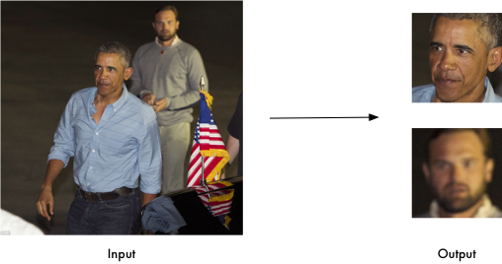

Figure 01

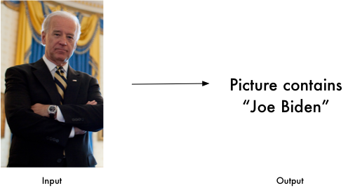

Figure 02

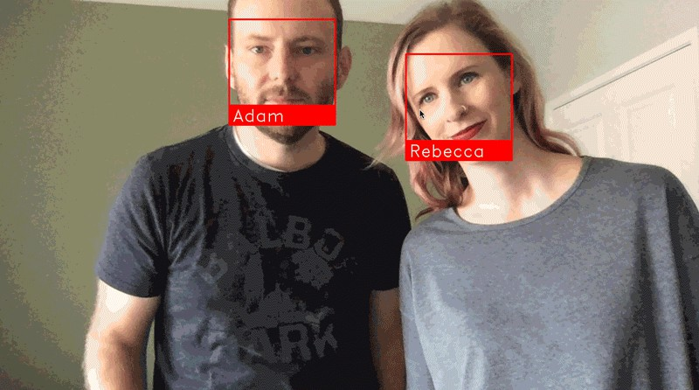

Figure 03

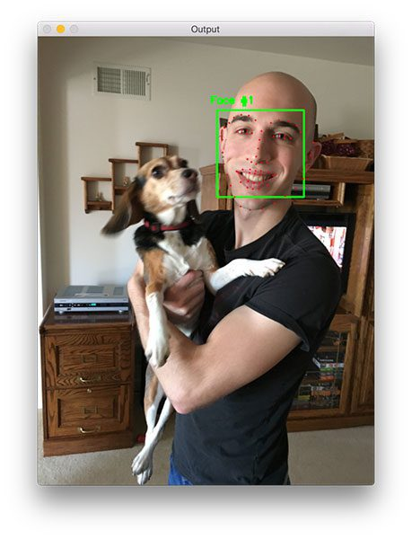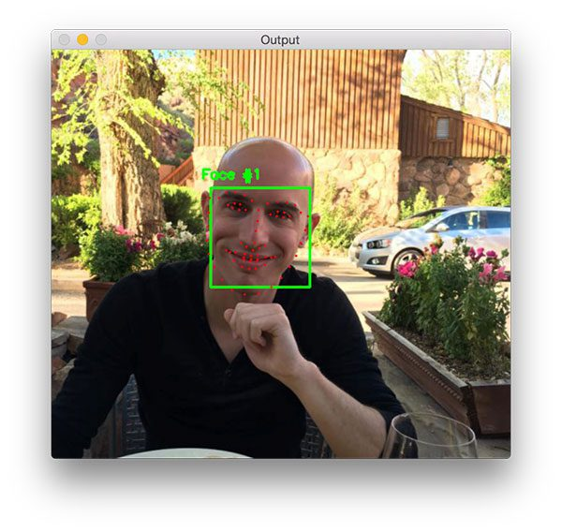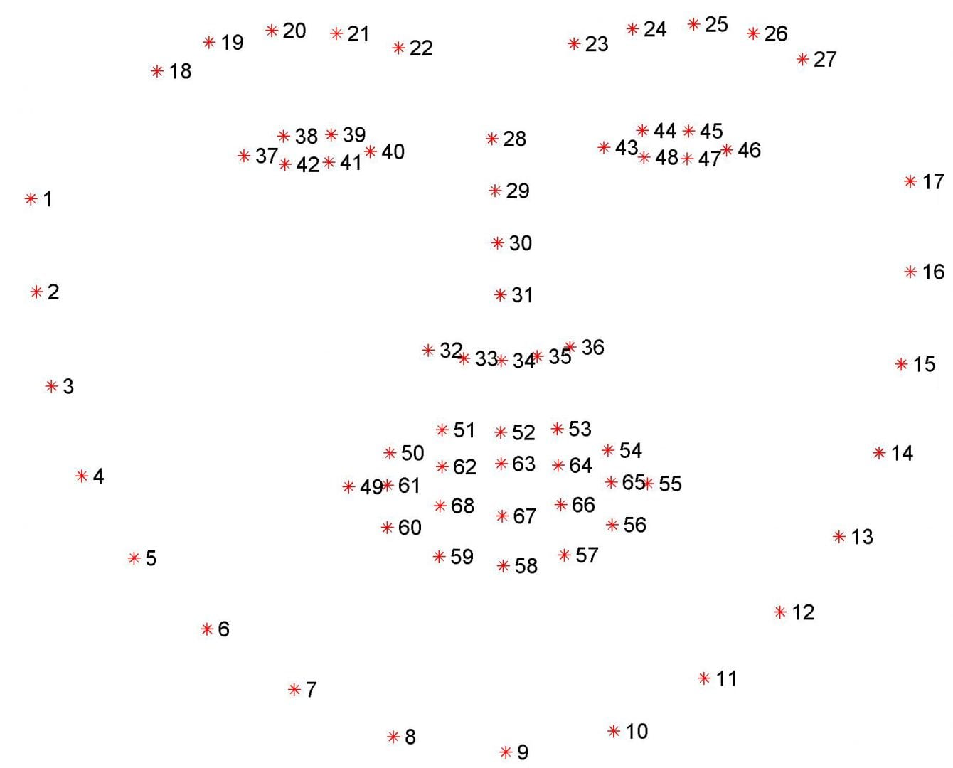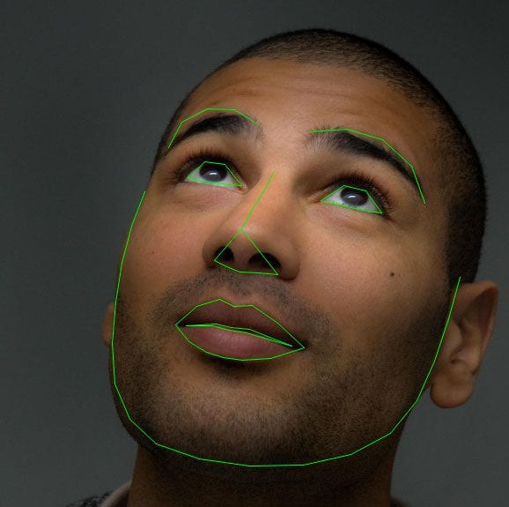

**05 Testing**

This is some footage from a live testing we made

* This how it looks when the student is present and not late (before the first 5 minutes from when the class started)

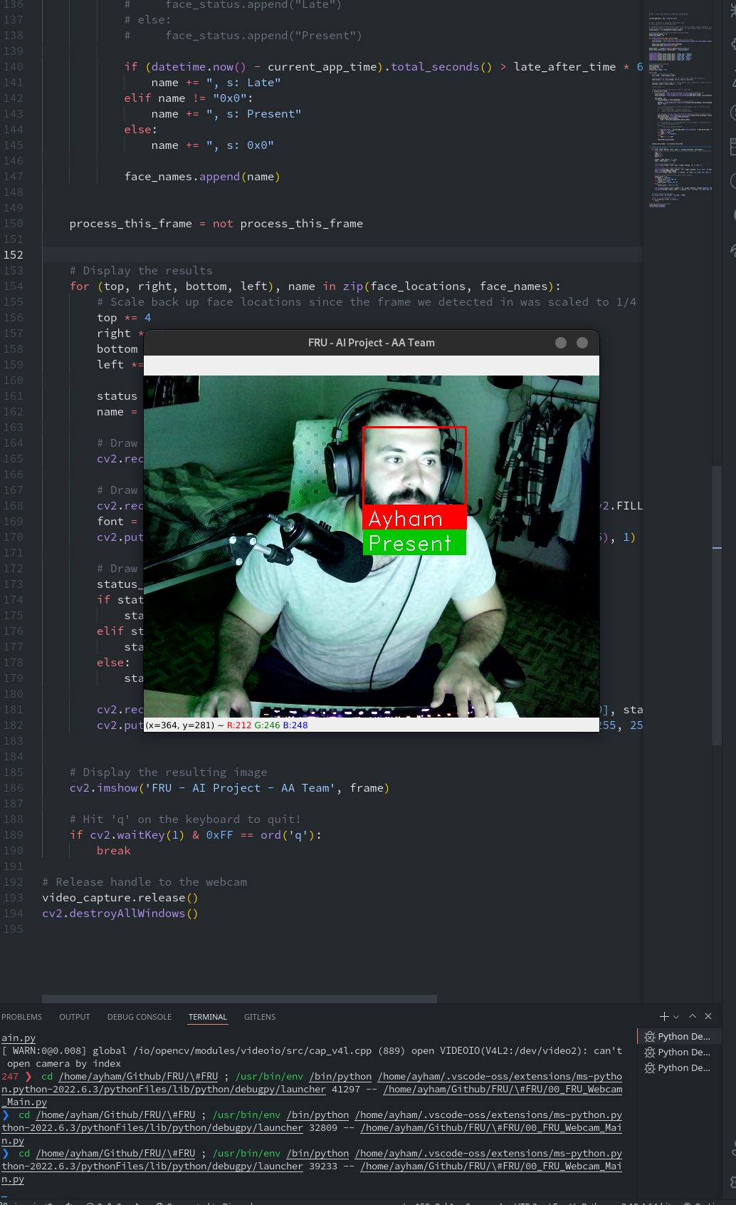

* This how it looks when the student is late (after 5 minutes from when the class started)

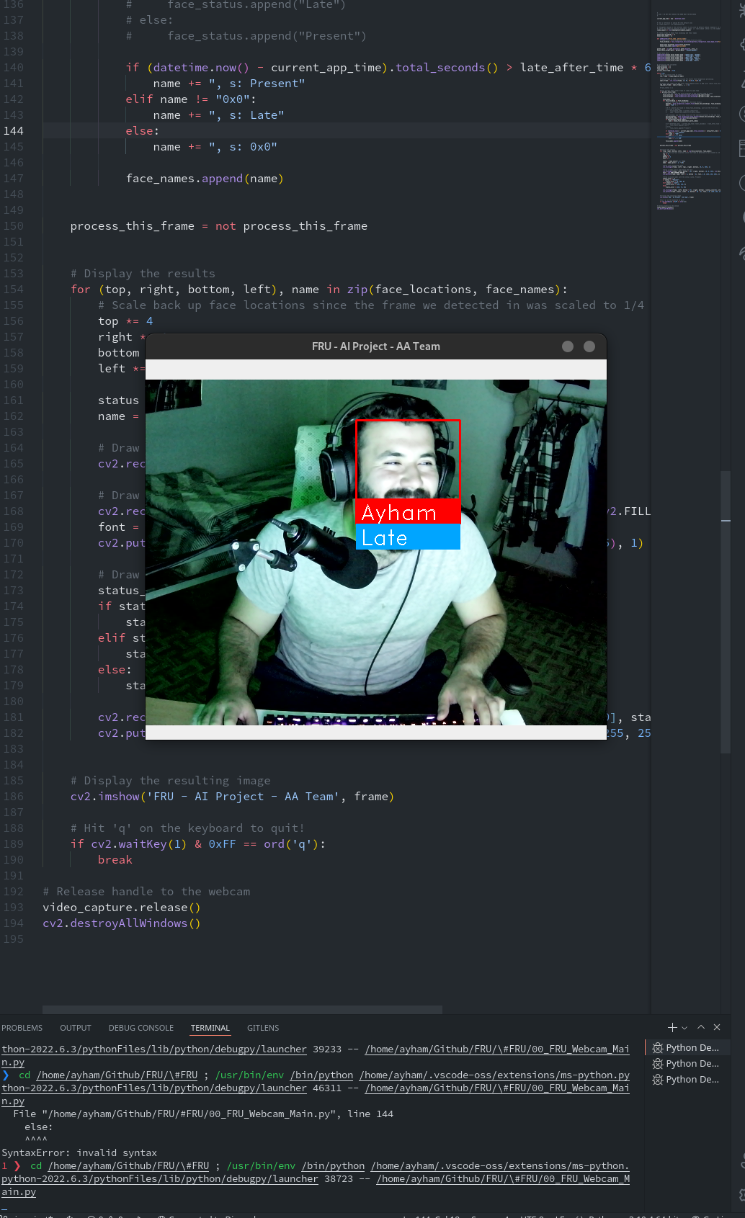

* This how it looks when the student face is not registered

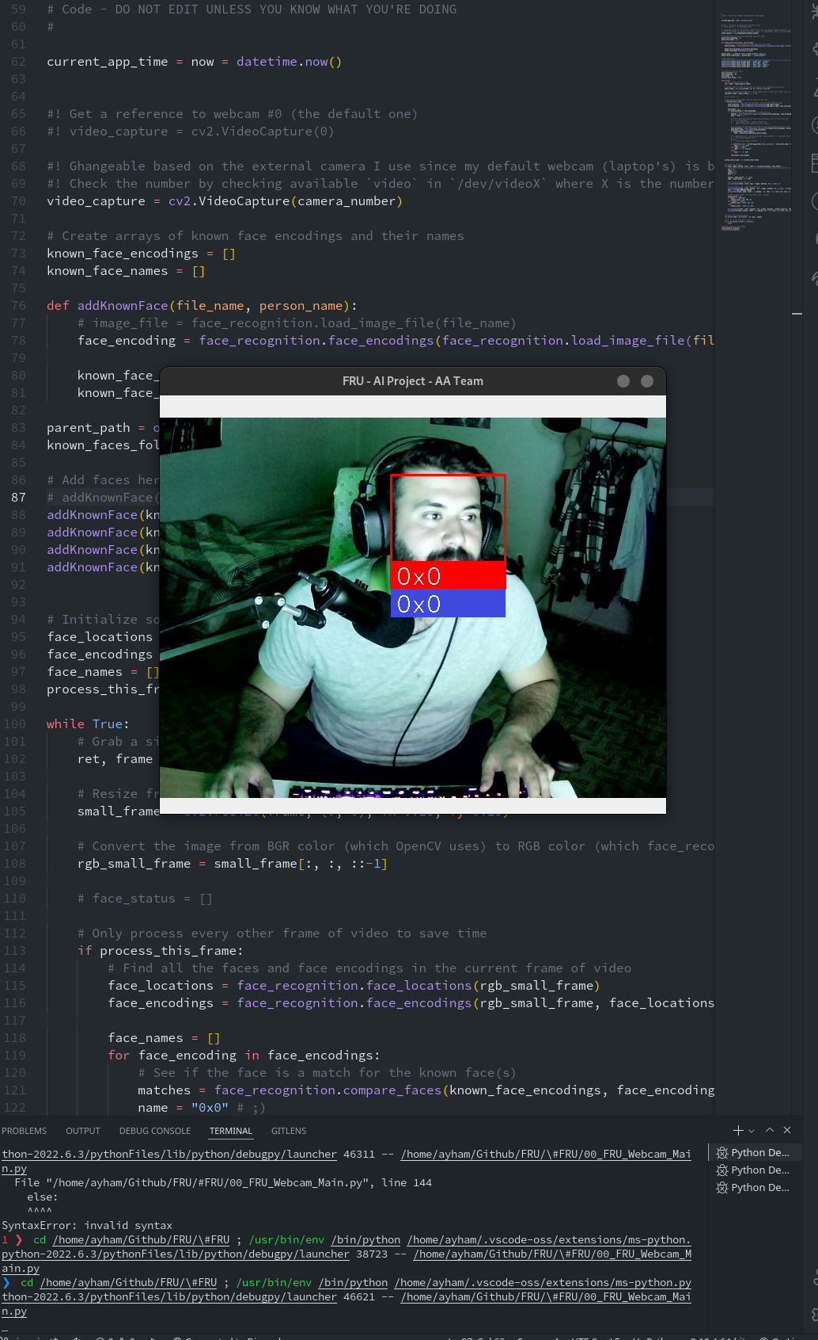

**06 Code Breakdown**

Here we will explain the main code blocks step by step:

* We import all the needed libraries

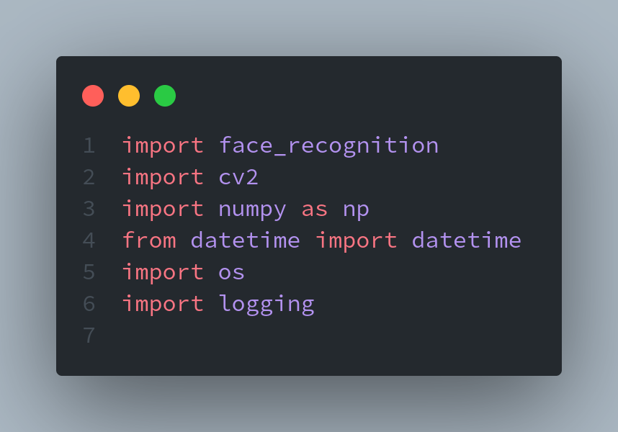

* Some options you can change

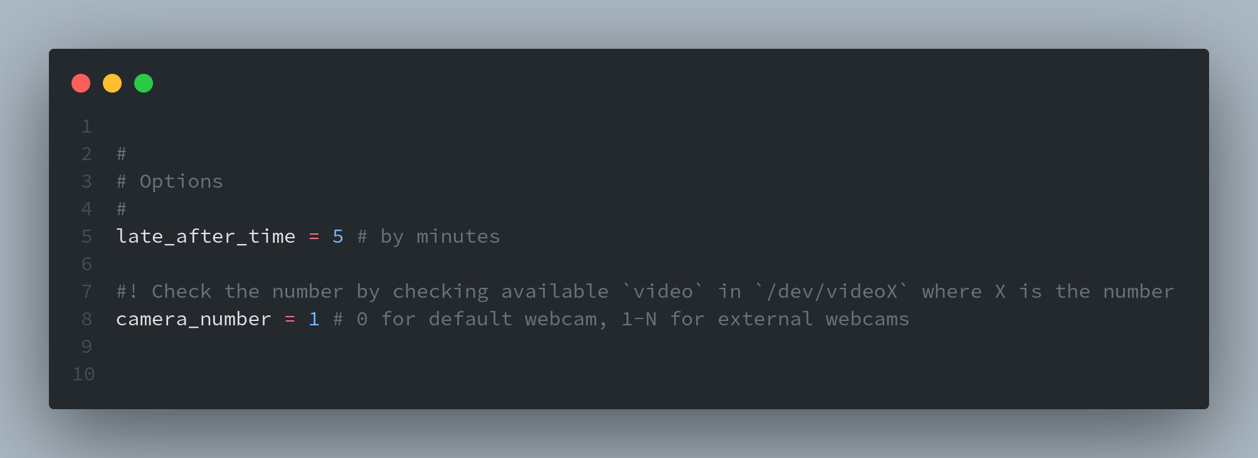

* Here we save the AI start time which is equal to the class time

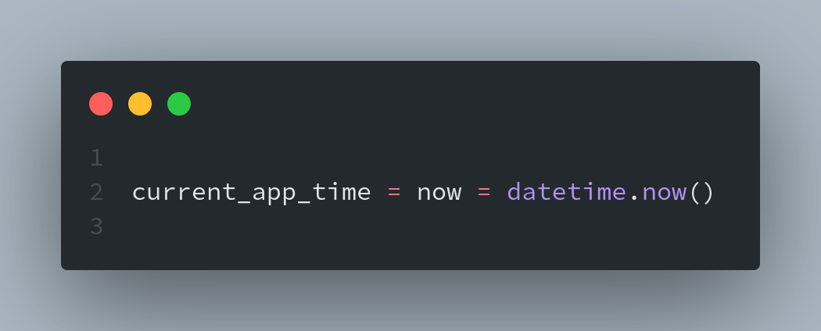

* We grab the webcam needed (0 for the default, 1-N for external webcams (in linux))

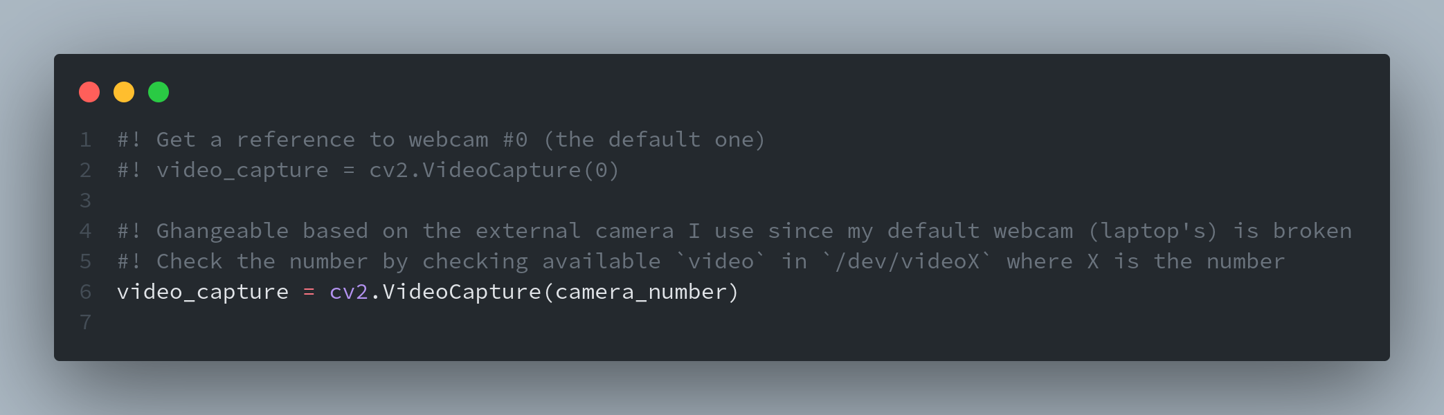

* Then we add known faces, these are the pictures of known faces that the AI will compare with then output the face name

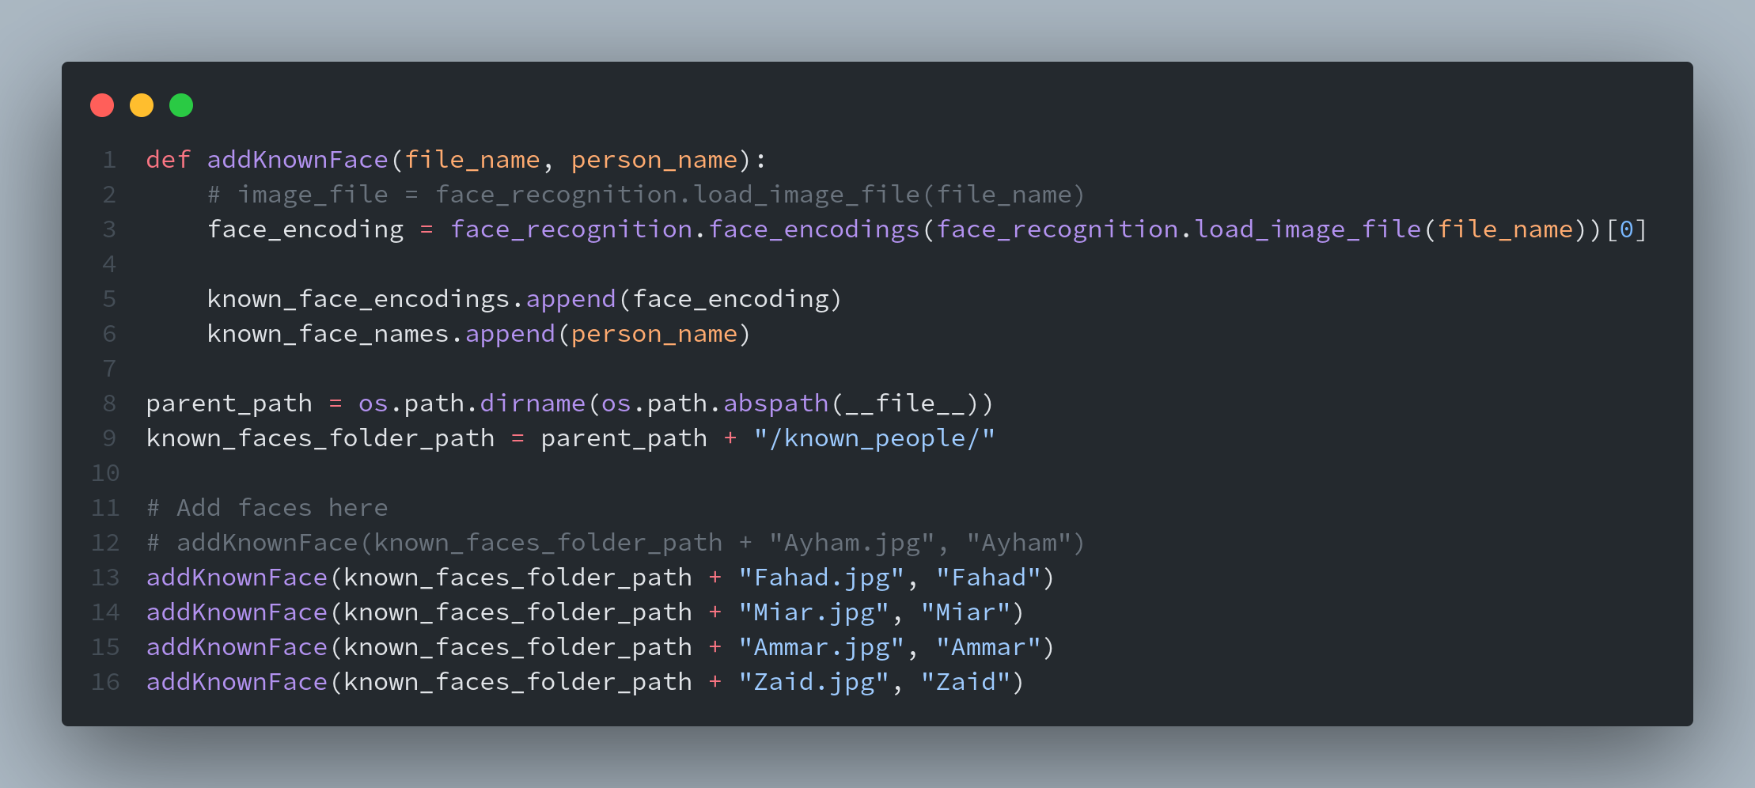

* Finally, Detection Code

